7. INTRODUCTION TO INTERNAL FLOW
INTERNAL FLOW: A flow through a conduit (without free surface), which is driven by pressure gradient.
INTERNAL FLOW | OPEN CHANNEL FLOW
No free surface. | Free surface present.
Pressure need not be atmospheric. | Pressure throughout the free surface is atmospheric.
Pressure varies throughout the flow. | Pressure throughout the flow remains constant.
Flow is driven by pressure forces/ Pressure Gradient. | Flow is driven by Gravitational Force.
E.g. Every Flow through pipe, etc… | E.g. flow in canal river, etc…
REYNOLD’S NUMBER ($Re$): It’s dimensionless number represent the ratio of inertia force to viscous force.
$$Re=\frac{F_{Ine.}}{F_{Vis.}}=\frac{ρVL}{μ}$$  Where, $L=$ Characteristic dimension,  $$L=D (in pipe flow)$$ | $$F_{Ine.}=ma=ρ∀ \left(\frac{dV}{dt}\right)∝ρV^{2}L^{2}$$ | $$here, ∀ ∝L^{3} \& \frac{dV}{dt}=\frac{dV}{ds}dV∝\frac{V^{2}}{L}$$
 | $$F_{Vis.}=τ_{Vis.}A_{s}=μ\frac{du}{dy}A_{s}∝μVL$$ | $$here, A_{s}∝L^{2} \& \frac{du}{dy}∝\frac{V}{L}$$

For flow through Pipe/ Duct,
$Re≤2000,$ Laminar Flow | $2000<Re≤4000,$ Transition Flow | $Re>4000,$ Turbulent Flow

DEVELOPMENT/ ESTABLISHMENT OF FLOW:  $$\frac{L_{e}}{D}=0.07 Re(For Laminar Flow)$$  $$\frac{L_{e}}{D}=50(For Turbulent Flow)$$  $L_{e}=$ Establishment entrance length, | 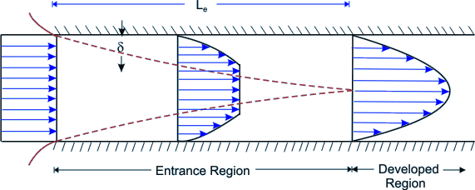
FUNDAMENTALS OF INTERNAL FLOW THROUGH PIPES:
CONDITIONS FOR VALIDITY OF THEORY:

- Flow must be steady. ($Q=Const.$)
- Flow must be fully developed.

EQUATION GOVERNING INTERNAL FLOW THROUGH PIPES:
$$F=P2πrdr$$ $$F+dF=\left(P+dP\right)2πrdr$$  $$F_{sf}=τ_{r}2πrdx$$ $$F_{sb}=τ_{r+dr}2π\left(r+dr\right)dx$$ | $r=$Radial Axis,  $x=$ Axis along the flow, |  | 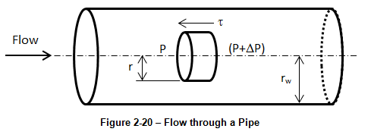
$$\sum{F_{x}}=0⇒-r\left(\frac{dP}{dx}\right)=\frac{{\left(τ_{r}\right)}_{r+dr}-{\left(τ_{r}\right)}_{r}}{dr}=\frac{d{\left(τ_{r}\right)}_{r}}{dr}$$
$$r\left(\frac{-dP}{dx}\right)=\frac{d\left(rτ_{r}\right)}{dr}(For avg. pressure)$$ |  | $$r\left(\frac{-∂P}{∂x}\right)=\frac{d\left(rτ_{r}\right)}{dr}(For Local pressure)$$
PRESSURE DROP:
Pressure decreases linearly along the length of flow,
$$P∝{\left(-x\right)}^{1}⇒P=C_{1}{\left(-x\right)}^{1}+C_{2}⇒\left(\frac{-dP}{dx}\right)=C_{1}=Constant (+ve)$$ | $$\left(\frac{-dP}{dx}\right)=\frac{∆P}{L}=Constant$$
SHEAR STRESS $\left(τ\right):$
$$\int_{rτ=0}^{rτ}{d\left(rτ\right)}=\left(\frac{-dP}{dx}\right)\int_{r=0}^{r}{r dr}⇒τ=\left(\frac{-dP}{dx}\right)\frac{r}{2}$$ | This equation is valid for steady and fully developed for any type of flow. E.g. Laminar, Turbulent, etc…
Conclusion:  - $τ$ increases with respect to radius.  - At the wall of the pipe shear stress is maximum known as boundary shear or wall shear stress$\left(τ_{0}\right)$.  $$τ_{0}=\left(\frac{-dP}{dx}\right)\frac{R}{2} \& \frac{τ}{τ_{0}}=\frac{r}{R}$$ | 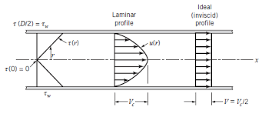

FRICTION COEFFICIENT & FRICTION FACTOR:  “The ratio of wall shear stress dynamic pressure is known as friction coefficient.”  FOR INTERNAL FLOW:  “Friction coefficient if known as fanning’s friction coefficient $(f’)$”  DARCY FRICTION FACTOR $\left(f\right)$: $f=4f^{'}$ |  | $$Friction Coeff.=\frac{τ_{0}}{\frac{1}{2}ρV^{2}}$$
 |  | $$f^{'}=\frac{τ_{0}}{\frac{1}{2}ρV^{2}}$$
MAJOR HEAD LOSS $\left(h\right)$:For inclined pipe, by using continuity equation and Bernoulli’s Equation, ${h=∆h}^{*}$(Piezometric head difference)  $$\sum{F_{x}}=∆\left(\dot{m}V_{x}\right)=0⇒P_{1}\left(\frac{πD^{2}}{4}\right)-P_{2}\left(\frac{πD^{2}}{4}\right)-W\sin{θ}-τ_{0}A_{s}=0$$  $$A_{s}=πDL$$ $$W=γ∀=γ\frac{πD^{2}}{4}L$$ $$τ_{0}=\frac{f}{8}ρV^{2}$$  $$h=\frac{fLV^{2}}{2gD}=\frac{4f^{'}LV^{2}}{2gD}(∵{h=∆h}^{*})$$  - Above Equation is known as Darcy-Weisbach Equation. | 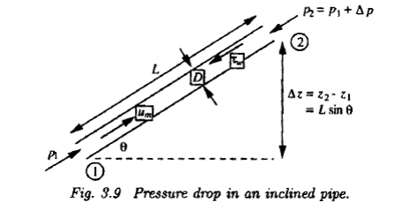

SUMMARY:
1 | Flow Governing Equation, | $$r\left(-\frac{dP}{dx}\right)=\frac{d\left(rτ\right)}{dr}$$
2 | Pressure Drop $∆P$ is positive in the direction of flow. | $$\left(\frac{-dP}{dx}\right)=\frac{∆P}{L}=Constant (+ve)$$
3 | Shear Stress or Wall shear Stress, | $$τ=\left(\frac{-dP}{dx}\right)\frac{r}{2} \& τ_{0}=\left(\frac{-dP}{dx}\right)\frac{R}{2} \& \frac{τ}{τ_{0}}=\frac{r}{R}$$
4 | Friction factor or friction coefficient, | $$f=4f^{'}$$
5 | Darcy-Weisbach Equation, | $$h=\frac{fLV^{2}}{2gD}=\frac{4f^{'}LV^{2}}{2gD}$$
NOTE: If the flow is non horizontal then, Replace every static pressure term by corresponding piezometric pressure.

